GIRLS

Pre-school, Pre-Primary and Primary

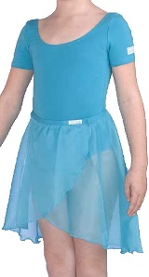
- Marine Freed “Chloe” leotard
- Marine Freed wraparound georgette skirt
- Pink ballet socks
- Pink leather full sole ballet shoes with pink elastics

Grades 1, 2 and 3

- Teal Freed “Aimee” Leotard in Meryl Fabric
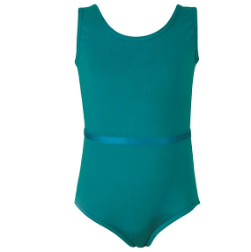
- Teal waist elastic
- Pink ballet socks or tights
- Pink leather full sole ballet shoes with pink elastics
- Black canvas character shoes with pink elastics – Cuban (higher) heel for grade 3 ONLY.
- Black character skirt with ribbons (Blues)

Grades 4 and 5

- Mulberry Freed “Faith” leotard in Meryl Fabric
- Mulberry waist elastic
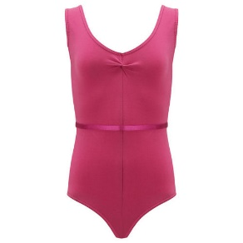
- Ballet tights
- Leather split sole ballet shoes with elastics
- Black canvas Cuban heel character shoes with pink elastics.
- Black character skirt with ribbons (Pinks)

Pointe – Prep

- Any colour or style leotard
- Convertible Ballet Tights
- Leather split sole ballet shoes

Grades 6, 7 and 8

- Burgundy leotard (any style matte lycra)
- Burgundy chiffon skirt – mid-calf length
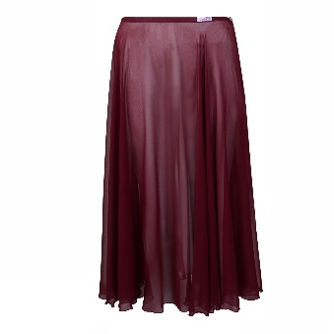
- Convertible ballet tights
- Leather split sole ballet shoes with elastics
- Black canvas Cuban heel character shoes with pink elastics
- Black character skirt with ribbons (pinks)

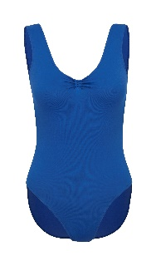
Intermediate Foundation

- Royal Blue “Bethany” Leotard in Meryl Fabric
- Pink convertible ballet tights
- Pink satin ballet shoes with ribbons
- Pink satin pointe shoes with ribbons

Intermediate

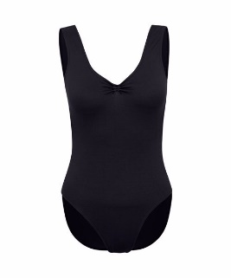
- Black “Bethany” Leotard in Meryl Fabric
- Pink convertible ballet tights
- Pink Satin soft-pointe shoes with ribbons
- Pink Satin Pointe shoes with ribbons

Advanced Foundation
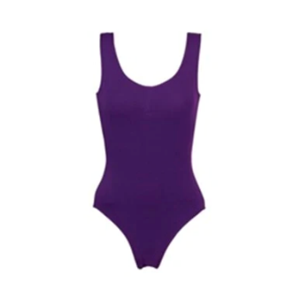
- Purple “Bethany” Leotard in Meryl Fabric
- *Optional* short purple chiffon wrap skirt
- Pink convertible ballet tights
- Pink Satin soft-pointe shoes with ribbons
- Pink Satin Pointe shoes with ribbons

Girl’s hair must be in a ballet bun for all classes grade 2 and above.

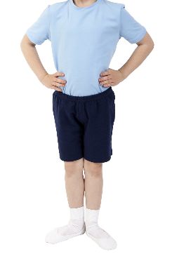
BOYS

Pre-school, Pre-Primary and Primary

- Marine Freed “Chloe” leotard or blue t-shirt
- Navy Shorts
- White ballet socks
- White leather ballet shoes with white elastics

Grades 1 – 3

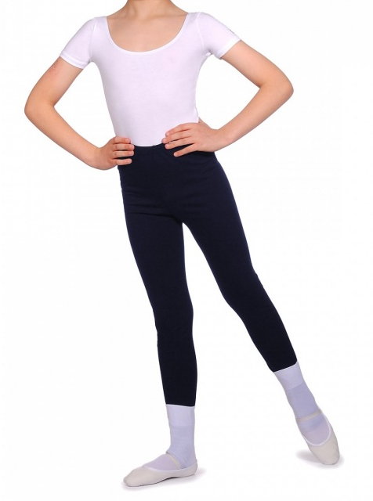
- Marine Freed “Chloe” leotard or white cap-sleeved leotard
- Navy shorts or stirrup tights
- White ballet socks
- White ballet shoes with white elastics
- Black canvas lace-up character shoes

Grade 4 upwards

- White cap-sleeved leotard
- Navy stirrup tights
- White ballet socks
- White split-sole ballet shoes with white elastics
- Black canvas lace-up character shoes

